
ITBP480: Senior Graduation Project I
Final Project Report
Spring 2026
TeachLens: AI-Based Classroom Teaching Evaluation System
Project ID: 11
Ali Mohammad Zainal : 202101929 Computer Science
Mohammad Alqaidy: 202205724 Computer Science
Abdallah Al Kaabi: 202108117 Computer Science
Ali Algaithi: 202106658 Computer Science

Nahyan Al Ali: 202100988 Information Security
Project Advisor: Dr. Hesham El Sayed
A project report submitted in partial fulfillment of the requirements for the Bachelor of Science degree at the
College of Information Technology, United Arab Emirates University
April 24, 2026

Executive Summary
In many universities, the primary way to evaluate a course and an instructor is through a short survey that students fill at the end of each semester. Even though this method aims to improve the curriculum and teaching methods, it is not as effective due to numerous reasons. Some students give high scores just because they like the subject or the instructor. Others give bad ratings because they were struggling during the course and didn’t like their grades. Many students, however, rush through the survey by clicking random choices just to finish it. Consequently, the results could be biased, and the instructors are not receiving clear and honest feedback about how effective their teaching actually was. And this issue keeps repeating every semester with almost no improvement in sight.
Our project’s idea is to solve this issue by using an AI-based teaching analytics system that uses video from the classroom to generate an evaluation of the teaching effectiveness of individual instructors. The project uses a high definition camera that records both the instructor and students during the class to gather video data that will be processed by the machine learning model to produce an accurate human readable report that the instructors could look at.
The system would track instructor behavior such as writing on the board, explanation of concepts, interaction with students, etc. It will also track student behavior such as paying attention, raising hands, speaking and asking questions, etc. On a later stage, the system would extract quantitative data from these features such as how long the instructor spent explaining without student interaction, how often the instructor engages with students, how active students are during different parts of the class, etc. Based on this, the system will then create an evaluation report for the instructor, which will include the strong points, parts that may need improvement, and/or simple suggestions to improve teaching style and classroom engagement.
The main goal of this project is to support university instructors with recorded classroom data void of emotions or bias. That way, they will receive more fair and honest feedback that will enhance the teaching abilities of instructors.

Contents
Table of contents . . . . . . . . . . . . . . . . . . . . . . . . . . . . . . . . . iii
List of tables . . . . . . . . . . . . . . . . . . . . . . . . . . . . . . . . . . . iv
List of Figures . . . . . . . . . . . . . . . . . . . . . . . . . . . . . . . . . . . v
- Introduction 1
  - Problem Statement . . . . . . . . . . . . . . . . . . . . . . . . . . . . . 2
  - Objectives . . . . . . . . . . . . . . . . . . . . . . . . . . . . . . . . . . 3
  - Expected Outcomes and Deliverables . . . . . . . . . . . . . . . . . . . 4
  - Motivation and Relevance . . . . . . . . . . . . . . . . . . . . . . . . . 5
  - Report Structure Summary . . . . . . . . . . . . . . . . . . . . . . . . 6
- Background and Related Work 7
  - Literature Review . . . . . . . . . . . . . . . . . . . . . . . . . . . . . . 7
  - Gap Analysis . . . . . . . . . . . . . . . . . . . . . . . . . . . . . . . . 10
  - Target Users or Stakeholders . . . . . . . . . . . . . . . . . . . . . . . . 10
- Requirements and System Analysis 11
  - Functional Requirements . . . . . . . . . . . . . . . . . . . . . . . . . . 11
  - Non-Functional Requirements . . . . . . . . . . . . . . . . . . . . . . . 12
  - Applicable Standards and Constraints . . . . . . . . . . . . . . . . . . . 13
  - Tools and Technologies . . . . . . . . . . . . . . . . . . . . . . . . . . 14
  - Feasibility and Risk Analysis . . . . . . . . . . . . . . . . . . . . . . . . 15
- Conceptual Design 18
  - System Design and Architecture . . . . . . . . . . . . . . . . . . . . . . 18
  - Technologies and Implementation Approach . . . . . . . . . . . . . . . 20
  - Data and Interface Design . . . . . . . . . . . . . . . . . . . . . . . . . 22
  - Ethical and Innovative Aspects . . . . . . . . . . . . . . . . . . . . . . 24

- Professional, Ethical, and Sustainability Considerations 26
  - Preliminary Cost Estimation and Justification . . . . . . . . . . . . . . 26
  - Relevant Codes of Ethics and Moral Frameworks . . . . . . . . . . . . . 27
  - Relevant Environmental Considerations . . . . . . . . . . . . . . . . . . 27
  - Relevance to UAE and Region (Social, Cultural, and Political) . . . . 27
  - Other Issues and Constraints (where relevant) . . . . . . . . . . . . . . 28
- Project Management Plan 29
  - Team Structure . . . . . . . . . . . . . . . . . . . . . . . . . . . . . . . 29
  - Work Breakdown Structure (WBS) . . . . . . . . . . . . . . . . . . . . 29
  - Timeline / Gantt Chart . . . . . . . . . . . . . . . . . . . . . . . . . . 29
- Conclusion and Future Work 32
- Statement of Contribution 34

List of Tables
3.1 Tools and Technologies Used in the Proposed System . . . . . . . . . . 14
3.2 Qualitative Risk Assessment and Mitigation Table . . . . . . . . . . . . 16
5.1 Preliminary Cost Estimation . . . . . . . . . . . . . . . . . . . . . . . . 26
8.1 Student Signatures . . . . . . . . . . . . . . . . . . . . . . . . . . . . . 34

List of Figures
1.1 Camera placement for recording video and processing instructor and
student behavior. . . . . . . . . . . . . . . . . . . . . . . . . . . . . . . | 2
4.1 Proposed AI-based classroom analytics pipeline. . . . . . . . . . . . . . | 19
4.2 Lagged statistical model method . . . . . . . . . . . . . . . . . . . . . . | 20
4.3 ER Diagram . . . . . . . . . . . . . . . . . . . . . . . . . . . . . . . . . | 22
6.1 Work Breakdown Structure (WBS) . . . . . . . . . . . . . . . . . . . . | 30
6.2 Gantt Chart SGP2 . . . . . . . . . . . . . . . . . . . . . . . . . . . . . | 30
6.3 Gantt Chart SGP2 . . . . . . . . . . . . . . . . . . . . . . . . . . . . . | 31

Chapter 1

Introduction
With the rapid advancement of technology across sectors such as healthcare, government, and organizations, its integration into higher education has become increasingly important. In this context, teaching quality is a key factor influencing student learning outcomes, academic performance, and classroom engagement.
Teaching effectiveness in higher education is commonly assessed through end-of-semester evaluations, student feedback, and occasional classroom observations. However, these methods often produce limited or unreliable insights. Student feedback may be shaped by personal opinions, emotions, grading expectations, or low response rates, while classroom observations are constrained by time and human subjectivity. Moreover, student engagement in face-to-face classes tends to decline when instruction relies heavily on prolonged passive listening and exceeds students’ cognitive capacity, reducing attention over time [1].
To address these limitations, this project proposes an AI-based teaching analytics system that uses classroom video data to generate more objective evaluations of teaching effectiveness. Recent advances in artificial intelligence, computer vision, and video analysis enable the detection of classroom behaviors and the extraction of meaningful patterns from real learning environments. Figure 1.1 illustrates the proposed camera placement for capturing and analyzing the behavior of both instructors and students in the classroom.
The system is designed to look at how instructors teach like when they explain things write on the board and ask the class questions. At the time it pays attention to how students interact with each other such as participating in discussions raising their hands and other signs that they are really engaged in the lesson. A study by Christian B. And Siv M. Showed that when students get feedback it really helps them improve their work especially for students who are still learning.. When students get indirect feedback it actually helps them to think more about what they are doing because they have to figure out what is wrong and fix it themselves which is a big part of the learning process, for students and their revision accuracy and student interactions and engagement[2]. This report highlights strengths in teaching performance, identifies areas that require improvement, and provides concise suggestions to enhance future class sessions. In this way, the project aims to support instructors by delivering fairer and more objective feedback based on recorded classroom evidence rather than relying solely on subjective opinions.
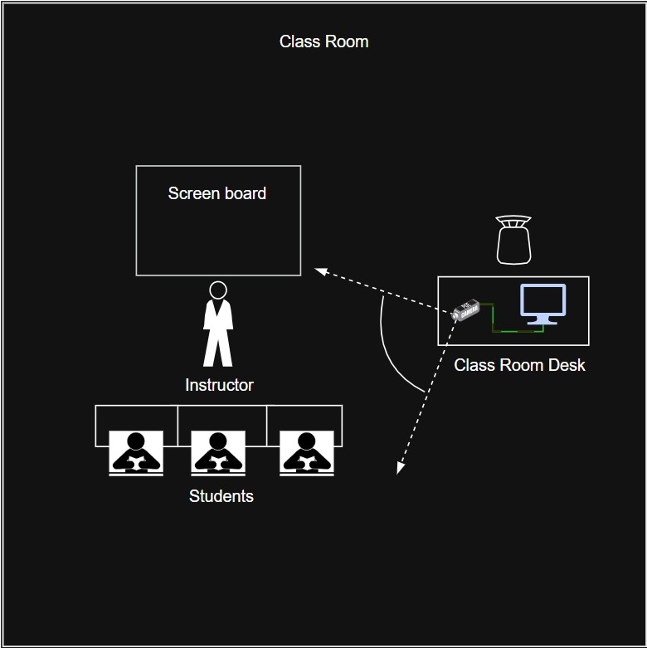
Figure 1.1: Camera placement for recording video and processing instructor and student behavior.

1.1 Problem Statement
Universities need ways to check if teaching is working well. This is because how well teachers teach directly affects how much students understand, how motivated they are, how engaged they stay and how well they do in their studies. Right now most universities depend on feedback from students, at the end of the semester and a few classroom observations. These methods often do not give a picture of how teaching and learning really work. Feedback given at the end of the term can be unclear or even negative. This can make students lose motivation and not want to learn. [2]. In addition, student course evaluations may be shaped by non-academic factors such as grades, personal preferences, and perceived course difficulty. As a result, these methods often lack the detailed behavioral evidence needed to identify which teaching practices effectively promote student engagement.
Traditional methods used to evaluate teaching effectiveness in universities, such as student course evaluations and peer observations, are associated with several significant limitations:
- Low response rates: A significant number of students either do not complete course evaluations or provide minimal and uninformative responses, which reduces the reliability and validity of the collected data.
- Lack of detailed behavioral insight: Traditional evaluation methods rarely capture when and how students lose attention, nor do they clearly identify which teaching strategies lead to the highest levels of student engagement.
In classrooms where the teacher and students are face to face you can tell if the teacher is doing a good job by looking at what the teacher does how the students react and how they all interact with each other.. Most of the time nobody writes down what they see. With education we need to find better ways to measure how well students are paying attention in class. We want to know if they are really learning. Some studies have already shown that if we look at lots of things like what peoples faces are doing how they are moving their bodies and how they turn their heads we can get a better idea of what is going on in the classroom and if students are really participating. This is, about student engagement and classroom behavior and student engagement [3]. Without such data, instructors may find it difficult to identify which parts of a lecture are engaging, confusing, or ineffective. This project therefore addresses the absence of an intelligent system that can automatically analyze classroom behavior and deliver clear, unbiased, and actionable feedback. By applying artificial intelligence to both teaching practices and student engagement, the proposed system seeks to improve the fairness and effectiveness of course evaluation while supporting better teaching outcomes.
A second challenge concerns camera configuration, namely whether a single camera can sufficiently capture both instructors and students or whether multiple cameras are needed. Although a multi-camera setup may improve coverage, it also increases system complexity through synchronization requirements and higher processing demands. Prior work similarly notes that multi-camera systems are more complex because they support wider spatial coverage, depth perception, and synchronized multi-angle imaging [4]. Camera placement adds another difficulty: a narrow view may capture the instructor clearly but miss student behavior, whereas a wider angle may include students at the expense of instructor detail. Since the proposed system evaluates both instructor and student behavior to generate a comprehensive teaching evaluation summary, selecting an appropriate camera setup is a critical technical issue, especially given the established link between classroom participation and academic performance [3].

1.2 Objectives
The main objective of this project is to design and develop an AI-based classroom analytics system that evaluates teaching effectiveness by analyzing both instructor behavior and student engagement using classroom video recordings. The system aims to provide instructors with structured feedback, highlighting positive teaching practices, identifying parts of the lecture that may be less effective, and analyzing levels of student engagement throughout different stages of the session.
This project focuses on integrating a multimodal approach that captures multiple factors related to teaching and learning. These include the instructor’s teaching style, level of interaction through questions and discussions, and student behaviors such as attentiveness, participation, distraction, or inactivity.
The project has the following specific objectives:
- Capture classroom behavior:
  - Use a camera to record both the instructor and students during live lectures.
  - Ensure that the setup captures key teaching and learning activities without disrupting the class.
- Detect and classify instructor behaviors:
  - Identify actions such as explaining concepts, writing on the board, using slides, moving around the classroom, and interacting with students.
  - Distinguish between teaching segments that are likely to have positive impact (e.g., clear explanations, active questioning) and segments that may have negative or limited impact (e.g., long monologues with no interaction). • Detect and classify student behaviors:
  - Analyze student engagement indicators such as paying attention, taking notes, raising hands, asking questions, and participating in discussions.
  - Detect disengagement behaviors such as using mobile phones, sleeping, or frequently looking away from the instructor.
- Generate an automated evaluation report:
  - Produce a human-readable summary for each recorded session that highlights:
∗ Positive aspects of the instructor’s teaching style.
∗ Negative or less effective aspects.
  - Provide simple, practical suggestions to help the instructor improve future classes.
These objectives guide the design and planning activities in SGP1

1.3 Expected Outcomes and Deliverables
By the end of the graduation project, the expected outcome is a working prototype of an AI-based teaching analytics system capable of analyzing classroom behavior and generating instructor feedback reports. The expected deliverables for SGP1 include:
Literature Review:
- A structured and critical review of related work in AI-based classroom analytics, computer vision techniques for behavior recognition, and existing approaches to teaching evaluation.
Problem Analysis and Requirements Specification:
- A clear and comprehensive definition of the problem domain, including the identification of functional and non-functional requirements, as well as system constraints.
System Architecture and Design:
- A high-level system architecture outlining the main components (e.g., data collection, preprocessing, machine learning models, and reporting module) and their interactions. This also includes detailed design representations such as use case diagrams, activity diagrams, and system flowcharts.
Data Collection and Dataset Plan:
- A well-defined plan for collecting and annotating classroom video data, including labeling instructor behaviors (e.g., positive and negative teaching segments) and student engagement patterns. Where applicable, the use of publicly available datasets or the development of an initial sample dataset will be considered.
Project Plan for SGP2:
- A detailed timeline and work breakdown structure covering implementation, system integration, and evaluation activities in SGP2. This includes the development of an initial prototype to demonstrate the feasibility of detecting basic behaviors (such as distinguishing between attentive and distracted students or identifying instructor actions like writing on the board), as well as preliminary testing and evaluation results to assess system performance including the audio system as an additional enhancement but will add more time and complexity.

1.4 Motivation and Relevance
The motivation for this project stems from the need to improve teaching quality and student learning through objective, continuous, and data-driven feedback. Although traditional evaluation methods remain useful, they often fail to provide fully unbiased and detailed insights into what actually occurs during classroom instruction. In contrast, an AI-based system can analyze classroom data and generate feedback based on real teaching and learning interactions as they happen. This makes it possible to capture meaningful indicators such as instructor actions, student behavior, and patterns of classroom engagement. Furthermore, when instructors better understand how their teaching style influences student engagement, they can adjust their methods to become clearer, more interactive, and more inclusive. As a result, this project supports the development of a more effective and student-centered learning environment.
From the perspective of the UAE’s strategic vision, this project aligns with national initiatives that emphasize innovation, digital transformation, and the integration of artificial intelligence across key sectors. It also reflects the broader national focus on quality, efficiency, innovation, and harmonisation as essential pillars of sustainable development, we provide the following link to the website: UAE National Strategy for Higher Education 2030. An AI-driven classroom analytics system supports these goals by enhancing the quality of education, enabling data-informed decision-making, encouraging the adoption of advanced technologies in higher education, and promoting continuous improvement in teaching and learning practices. The following aspects demonstrate how the proposed system can contribute to the advancement of education:
- Encouraging the adoption of AI solutions in everyday educational practices.
- Providing data to support quality assurance and accreditation processes.
- Enhancing the reputation of local universities as early adopters of smart education technologies.
From a computing and research perspective, this project is closely connected to several important areas within computer science and information technology, particularly computer vision, machine learning, human–computer interaction, and educational technology. It offers a valuable opportunity to examine how multimodal data, such as videos can be used to analyze complex human behaviors and classroom interactions in a real educational setting. Overall, the project aims to make both a practical and academic contribution by proposing a system that can support the improvement of teaching practices while also expanding the use of artificial intelligence in the field of education.

1.5 Report Structure Summary
The remainder of this report is organized as follows:
- Chapter 2 presents the background and related work. It includes the literature review, the gap analysis, and the identification of the target users and stakeholders of the proposed system.
- Chapter 3 will include the requirements and system analysis. It discusses the functional and non-functional requirements, the applicable standards and constraints, the tools and technologies to be used, and the feasibility and risk analysis of the project.
- Chapter 4 will discuss the conceptual design of the proposed system. It covers the system design and architecture, the technologies and implementation approach, the data and interface design, ER diagram, the system pipeline, and the ethical and innovative aspects of the project.
- Chapter 5 will include the professional, ethical, and sustainability considerations of the project. It includes the preliminary cost estimation and justification, relevant codes of ethics and moral frameworks, environmental considerations, the relevance of the project to the UAE and the region, and other related issues and constraints.
- Chapter 6 will discuss the project management plan. It describes the team structure, the work breakdown structure, and the timeline of the project in the form of a Gantt chart.
Chapter 2

Background and Related Work

2.1 Literature Review
We identified numerous researches that asserted that AI and computer vision could be used to study classroom interactions in a more direct way than normal end-of-semester surveys. One of the main papers related to our project is a paper by Wang, Hui (2025) [5] This paper proposes using classroom video to evaluate teaching by looking at 4 dimensions: teacher behavior, language expression, student understanding, and student participation. It explains that visual analysis in teaching evaluation usually follows the following flow: classroom video is collected, the video is preprocessed, and teacher and student behaviors are extracted and quantified. [5] We used their flow for our own project as their idea follows our own with classroom recording, behavior analysis, and we added a final stage of a final report generation for instructors.
The same paper also gives useful indicators we should measure to identify teaching effectiveness. On the teacher side, it includes indicators such as explanation time, number of interactions with students, and board writing. On the student side, it includes hand raises, answer to questions, participation, attention, and cooperative learning. It also adds language related indicators such as grammatical correctness, semantic clarity, logical coherence, speaking rate, and clarity of explanation [5].
Another paper by Trabelsi et al. [6], focused more on the student side of the classroom and builds a real-time system to monitor their behavior, emotions, and face detection and recognition from classroom video [6]. The paper divided student attention into high and low attention categories. High attention included focused and raising hands, while low attention included boredom, eating or drinking, laughing, reading, using a phone, distraction, and writing in some cases [6].
The same paper is also useful because it clearly shows the tools and what each one was used for. YOLOv5 was the main object detection model used to recognize student behavior and facial emotion from classroom images and video. DeepSORT was used for tracking, so each detected student could be followed across frames and their behavior could be linked over time. Kalman filter was an important part of the DeepSORT algorithm to help estimate object movement between frames. RoboFlow was used to augment and resize the dataset before training. LabelImg was used to annotate images and save bounding-box labels for training. AffectNet was used as the emotion dataset for facial expression training. MaskTheFace was used to create masked face images so that the emotion model could still work in cases where students wore face masks. The system also used OpenCV to access camera stream, NumPy for array handling, and Matplotlib and pandas for data handling and visualization [6]. The tools mentioned could give us an idea of what to use not only for tracking students, but tracking instructors as well. It also shows the full workflow from data collection to training, tracking, emotion recognition, and output storage.
The paper also compared different versions of YOLOv5, namely YOLOv5n, YOLOv5s, YOLOv5m, YOLOv5l, and YOLOv5x. Even though the larger models reached slightly better precision and recall, the paper chose YOLOv5s for the actual classroom system because it gave a better balance between speed and accuracy for real-time use [6], something we should be reconsidering for our use since our system won’t be real-time.
The study by Liu et al. (2025) [7] is a systematic review that gives a wider picture of classroom behavior recognition using computer vision. It reviewed 80 articles and found that the main recognition goals in this topic are physical action, learning engagement, attention, and emotion [7]. It also found that most studies were done in higher education classrooms and that most of them used cameras as the main collection device [7]. This is close to our own setting since our project is also aimed at university classrooms and depends mainly on video taping classrooms.
The review is also useful because it compares the methods used in earlier work. It shows that older machine learning approaches often used hand-made features such as body keypoints, facial landmarks, head pose, HOG, LBP, LDP, Gabor, and motion features like velocity and movement statistics. In contrast, newer work relies more on deep learning because it can learn features by itself and usually gives better recognition results in complex classroom environments [7]. The review states that deep learning was the main method in most of the studies they examined, and that the YOLO series was one of the most widely used model families across multiple classroom behavior tasks [7], which we were considering to use from the previous study.
The same review also points to other effective model families used in classroom analysis. Besides the YOLO series, it mentions CNN-based models, ResNet-based models, Transformer-based models, VGG, and SSD-based models for different classroom recognition tasks [7]. It also shows that some recent work combines spatial and temporal information from video to improve behavior detection, while some other work adds surrounding small-object information to improve accuracy in classroom scenes where actions can be small or partly hidden [7].
Another useful point from this paper regarding what could go wrong with the models. It mentions common problems such as occlusion, lighting changes, multi-scale detection issues, limited training datasets, motion blur, weak generalization across different classrooms, privacy issues, and the need for more links between recognized behavior and actual teaching performance [7], something that we should look more at as behavior detection alone is not enough.
Wang & Wu (2025) [8] adds more detail on the actual recognition methods that can be used inside classroom systems. It explains that facial analysis can be done through local facial features or whole-faced methods, and it mentions feature extraction methods such as edge-based, texture-based, global-plus-local, and geometry-based methods [8]. It also discusses DLIB, which was used to obtain 68 facial landmark points for face analysis, and explains that these points can help in tracking expressions and head posture over time [8]. We could leverage this because student attention and emotion may sometimes be better captured from facial landmarks than from broad image classification alone.
The same paper also discusses AdaBoost with Haar-like features and OpenCV classifiers for face detection, especially in cases where side-face detection is needed because students are not always facing the camera directly, and our camera setup might not be at the center of the classroom [8]. It also used contour detection to study image shapes and compare student and teacher behavior patterns, since student scenes tend to have more visual complexity while teacher scenes are often simpler in shape [8]. These methods that were mentioned may not be the best deep learning choices, but they still show us useful ways to detect visual signals when classroom scenes are noisy. For body movement analysis, the same paper presents OpenPose as a useful method for human joint detection and posture recognition. It explains that OpenPose can output body skeleton joints, and that these joints can be used to detect actions such as sleeping posture and other classroom body states [8]. This is helpful for our system because many student actions, such as raising hands, leaning, sleeping, or active listening, depend more on body pose than on facial expression alone. We could add this method along with the other methods mentioned in Trabelsi et al.’s paper for more accurate detections and recognitions.
The same paper also compares major target detection methods. It describes SSD as a single stage detector that is faster than older region-based methods and suitable for real-time object detection. It also describes YOLO as fast and strong for realtime detection because it performs localization and classification in one pass. It also describes R-CNN as more accurate in some cases, but slower and heavier because it first generates regions of interest and then classifies them [8]. It also mentions using a YOLO-based network for classroom state analysis because it can quickly assess student learning situations and support teaching adjustment [8]. This adds to our comparison of which methods to use for our own system, and to do our own tests in order to find the best method suitable for our application.
Overall, the reviewed studies support the main idea of our project. They show that classroom video can be used to capture teacher behavior, student attention, participation, and even emotional or engagement signals. They also show that deep learning, especially the YOLO family and related detection methods, is widely used for classroom behavior recognition, while pose estimation, face analysis, tracking, and audio related features can add more useful and accurate details. At the same time, the reviewed work also shows that there are still problems we should consider with camera angle, occlusion, lighting, privacy, generalization, and the need to connect technical outputs with actual teaching quality. These points are directly related to our project, since our goal is not just to detect behavior, but to turn those behaviors into a teaching evaluator as well.

2.2 Gap Analysis
After reviewing the related studies, it is clear that a lot of useful work has already been done in classroom analysis. Existing research has shown that classroom video can be used to detect student attention, engagement, emotion, and physical actions.
However, several limitations still appear in the current solutions. Many studies are affected by real classroom problems such as occlusion, lighting changes, motion blur, and image quality issues. Some also depend on limited or unbalanced datasets, which can reduce performance and make the model less reliable in different classroom settings [7]. Another issue is that some systems focus on only one side of the classroom, such as student attention only, without linking it to teacher behavior or overall teaching quality. The review paper also pointed out other problems such as weak generalization across different classrooms and student groups, lack of external verification, privacy concerns, high computing cost, and difficulty in handling similar or overlapping behaviors [7].
Our project will try to fill these gaps by taking a wider view of the classroom. Instead of focusing only on student attention or only on teacher actions, our system aims to analyze both instructor behavior and student engagement together. It also goes beyond simple behavior detection by generating a human-readable report with strengths, weak points, and suggestions. This makes the system more useful for actual teaching improvement. Another point that makes our project different is that it is meant for a university setting where both Arabic and English may be used, while many existing systems were designed for more limited language settings. In case we decide to implement audio extraction and analysis, we should consider a multi-language NLP model for a much accurate evaluation.

2.3 Target Users or Stakeholders
The target users of the proposed system include faculty instructors, government educational institutions, academic departments, and other project development teams. Faculty instructors are the primary users, as they can use the AIgenerated reports to review their teaching performance and improve their instructional methods. Government educational institutions and academic departments may use the system outputs to support teaching evaluation, monitor instructional quality, and assist in educational decision-making. In addition, other project development teams may benefit from the system as a reference for designing or improving similar educational technologies. The main stakeholders in this project are instructors and students, as they are the groups most directly affected by the system. Instructors are influenced through the feedback provided by the generated reports, which may shape their teaching practices and classroom strategies. Students are also key stakeholders because their classroom behavior and engagement form part of the input data analyzed by the system, and they may be affected by any instructional improvements that result from the system’s feedback. We found an article that information systems do support educational institutions function by providing tools to support planning, monitoring and evidence based, this can help into adopting such an approach [9].
Chapter 3

Requirements and System Analysis

3.1 Functional Requirements
- FR 1: Video Input
  - FR 1.1 The system shall allow an authorized user to upload or select a saved classroom lecture video for analysis.
  - FR 1.2 The system shall validate the uploaded video format before analysis begins.
- FR 2: Video Preprocessing
  - FR 2.1 The system shall extract video frames and timestamps from the saved classroom lecture video for later analysis.
  - FR 2.2 The system shall preserve the time position of each processed frame so that all later detections can be traced back to the original lecture time.
  - FR 2.3 The system shall allow the analysis session to use a predefined classroom configuration, including teacher zone, board region, and student seating region.
- FR 3: Instructor Analysis
  - FR 3.1 The system shall detect the instructor in the lecture video and assign instructor detections to a single instructor timeline.
  - FR 3.2 The system shall identify visible instructor actions relevant to teaching evaluation.
  - FR 3.3 The system shall assign a start time, end time, label, and confidence value to each detected instructor event.
- FR 4: Student Analysis
  - FR 4.1 The system shall detect predefined student-seat regions in the lecture video.
  - FR 4.2 The system shall identify visible student engagement-related behaviors.
  - FR 4.3 The system shall assign a start time, end time, label, confidence value, and seat identifier to each detected student event.
- FR 5: Indicator Calculation
  - FR 5.1 The system shall compute instructor-side indicators from detected instructor events.
  - FR 5.2 The system shall compute student-side indicators from detected student events.
- FR 6: Fusion and Temporal Linking
  - FR 6.1 The system shall align instructor outputs and student outputs on one shared lecture timeline.
  - FR 6.2 The system shall divide the lecture into fixed analysis windows for joint teacher-student analysis.
  - FR 6.3 The system shall perform lag-based analysis to check whether changes in student indicators tend to occur after specific instructor actions.
  - FR 6.4 The system shall record the lag value, compared variables, and analysis result for each detected teacher-student relationship.
- FR 7: Result Presentation
  - FR 7.1 The system shall generate a structured evaluation result that includes instructor indicators, student indicators, and teacher-student linkage findings.
  - FR 7.2 The system shall generate a human-readable report summarizing strengths, weak points, and evidence-based observations from the processed lecture.
  - FR 7.3 The system shall include supporting evidence in the report output, such as indicator values, timestamps, or referenced event windows.

3.2 Non-Functional Requirements
- NFR 1: Performance
  - NFR 1.1 The system shall process a recorded classroom lecture in offline mode within an acceptable analysis time on the designated project hardware.
  - NFR 1.2 The system shall preserve correct timestamp alignment between detected events and the original lecture video.
- NFR 2: Security and Privacy
  - NFR 2.1 The system shall allow only authorized users to upload lecture videos, run analyses, and view generated reports.
  - NFR 2.2 The system shall use anonymous student or seat identifiers in outputs and reports instead of student names.
- NFR 3: Usability
  - NFR 3.1 The system shall provide a clear and understandable workflow for uploading a lecture video, starting analysis, and viewing the final report.
  - NFR 3.2 The system shall display understandable error messages when invalid input or processing failure occurs.
- NFR 4: Scalability
  - NFR 4.1 The system shall support analysis of lectures of different durations without requiring changes to the core system workflow.
  - NFR 4.2 The system shall allow additional instructor or student indicators to be added later without redesigning the whole system.
- NFR 5: Reliability and Maintainability
  - NFR 5.1 The system shall produce consistent results when the same lecture video is processed more than once using the same configuration.
  - NFR 5.2 The system shall separate preprocessing, instructor analysis, student analysis, fusion, and report generation into distinct modules to simplify future modification and maintenance.

3.3 Applicable Standards and Constraints
Applicable Standards
- IEEE/ISO/IEC 29148 (Requirements Engineering): Guides the writing and organization of clear, consistent, and verifiable system requirements.
- ISO/IEC 25010 (Software Quality Model): Supports important quality attributes such as usability, reliability, maintainability, performance, and security.
- ISO/IEC 27001 (Information Security): Provides guidance for secure storage, controlled access, and protection of classroom video data.
- NIST Privacy Framework: Helps guide privacy-aware handling of personal data and reduction of privacy risks.
- UAE Personal Data Protection Law (PDPL): The system may process personal data from classroom recordings in the UAE.
- Research Ethics and Educational Fairness: Ensures informed consent, fair use of recordings, and respectful treatment of both students and instructors.
Constraints
- Privacy and Ethical Constraints: Classroom recording requires permission and data must be used only for approved academic purposes.
- Data Availability Constraint: Real classroom datasets may be limited, so public videos may be needed for early testing.
- Hardware Constraint: Training and video analysis may require GPU resources, which can limit speed and experimentation.
- Camera Placement Constraint: Poor camera angle, lighting, or occlusion can reduce detection accuracy.
- Model Limitation Constraint: Pre-trained models may not fully capture classroom behavior or mixed Arabic-English teaching without adaptation.
- Accuracy Constraint: The system may not be fully accurate in all cases because of lighting, occlusion, and behavioral variation.

3.4 Tools and Technologies
Table 3.1: Tools and Technologies Used in the Proposed System
Stage | Tool/Technolog | y Justification
Training | Python | Main programming language for model training, preprocessing, analysis, and reporting, it’s suitable because it has strong support for machine learning, computer vision, data analysis, and scientific computing.
Training | PyTorch | Deep learning framework for training the instructor and student models.
Training | Ultralytics  YOLO11m | Instructor behavior detection model. It’s suitable for instructor analysis because the instructor is usually a larger and clearer target in the frame, so a medium model is enough while still giving strong accuracy.
Training | Ultralytics  YOLO11l | Student behavior detection model. It’s more suitable for student analysis because classroom scenes are more crowded and student actions are smaller and harder to detect.
Training | YOLO Pose  Model | Pose-based support for actions such as hand raising, head-down posture, and board-writing posture.
Training | LabelImg | Manual annotation of classroom images. It allows bounding-box labeling in YOLO-compatible format, which makes dataset preparation easier.
Training | Roboflow | Dataset preprocessing, resizing, and augmentation to standardize images and improve dataset quality
Training | AffectNet /  MaskTheFace | Emotion dataset support and masked-face sample generation for emotion training.
 | FFmpeg | Video conversion, frame extraction, and timestamppreserving preprocessing.
Deployment
Stage | Tool/Technolog | y Justification
 | OpenCV | Video reading, frame handling, cropping, drawing detections, and preview generation. It supports frameby-frame video processing and region-based operations needed by the system.
 | NumPy | Storage and processing of arrays such as coordinates, masks, and frame-level features.
 | pandas | Storage of structured outputs such as events, indicators, and fused time windows.
 | SciPy | Cross-correlation and numerical support for lag analysis. It supports numerical operations needed to study delayed relationships between teacher and student outputs.
 | statsmodels | Lagged statistical modeling of teacher-student relationship. It is suitable for interpretable regressionbased analysis and time-lagged modeling.
 | Matplotlib | Visualization of results such as attention trends and indicator plots. It allows clear graphs to be generated for the final report and result interpretation.
Reporting | Jinja2 | Template-based report generation. It converts structured outputs into a readable report in a controlled and traceable way.
Reporting | Text-based LLM | Rewriting of structured outputs into smoother humanreadable text. It can improve wording, but the main report content should still come from verified structured results.
Hardware | GPU-enabled workstation / cloud GPU | Training and large-scale offline inference. GPU resources are needed because video-based model training and testing are computationally expensive.

3.5 Feasibility and Risk Analysis
Technical feasibility: The project will be implemented using several available technical models and tools, including DeepSORT and YOLO11 and many real-time or postprocessing software that support classroom behavior analysis. They are accessible in their Github repositories.. Beside that, project is mainly considering YOLO as the primary image and video analysis model, since it supports multimodal input. The main technical requirements include a classroom camera with sufficient storage capacity
Operational feasibility: The proposed system is operationally feasible because models such as YOLO11 can be integrated into a real classroom environment. The system will rely on a camera to record the classroom session while the lecture is taking place, after which the selected models can be used to analyze instructor and student behavior from the recorded data.
Economic feasibility: From an economic perspective, the project is partially supported by open-source resources available on GitHub and other sources. However, many related university research projects only publish their articles and experimental results without releasing the full datasets, trained models, or classroom recordings (privacy reasons). In some cases, only model names and figures are provided. Requests have been sent to some authors by email, and responses are still pending. Even so, the availability of open-source tools and published studies helps reduce the overall development cost of the project.
Schedule feasibility: The tools, technologies, and system requirements identified in the previous sections can be combined to support project execution. Although the final project schedule has not yet been fully determined, the current recommendation is to allocate approximately eight months for the next implementation stage, subject to further revision based on progress and project needs.
Risk analysis: Several challenges may affect the success of the proposed project. These risks include privacy concerns, camera placement, recordings/datasets availability .... . In addition, other risks identified in this following table:
Table 3.2: Qualitative Risk Assessment and Mitigation Table
Asset | Sensitivity | Likelihood | Mitigation
Recorded classroom video and extracted  frames | High | High | Process all video locally, encrypt stored files, restrict access using role-based controls, minimize retention time, and delete raw video after feature extraction where feasible.
Direct identity data (student names, photos, seat-name mapping) | High | Medium | Avoid collecting direct identifiers where possible, use anonymous seat IDs, and store any required mapping separately under strict faculty control.
Consent, notice, and governance records | High | High | Provide clear notice, define purpose limitation, obtain consent/approval before collection, document retention and access rules, and maintain accountability records.
Structured event logs, dashboards, and generated reports | High | Medium | Apply least privilege, role-based access control, audit logging, export restrictions, and data minimization to prevent misuse or overexposure of behavioral information.
Third-party AI tools and external GPU/cloud services handling raw data | High | Medium | Keep sensitive processing on approved local or university-managed infrastructure, deidentify data before any external use, and avoid sending raw classroom video to public services.
Training compute /  GPU capacity | Moderate | Medium | Use university lab resources or approved managed infrastructure, schedule training jobs efficiently, and maintain smaller fallback models for constrained environments.
Camera placement and recording setup | Moderate | Medium | Perform classroom calibration before deployment, verify field of view, avoid capturing unnecessary spaces, and test placement to reduce blind spots and privacy overreach.
Dataset availability and preprocessing pipeline | Moderate | Medium | Use approved public datasets plus curated classroom samples, standardize preprocessing steps, document the pipeline, and version-control data preparation scripts.
Asset | Sensitivity | Likelihood | Mitigation
Behavior recognition model outputs (accuracy / inaccuracy  risk) | Moderate | High | Validate models on representative clips, apply confidence thresholds, include human review for uncertain cases, and iteratively retrain using observed failure cases.
Seat-based tracking logic when students change seats | Moderate | Medium | Reinitialize seat mapping for activity-heavy segments, allow manual correction of seat assignments, and flag uncertain seat transitions for review instead of forcing incorrect tracking.
Multimodal / audio integration module for  SGP2 | Moderate | Medium | Keep audio optional, require additional consent before collection, separate the audio pipeline from the video baseline, and defer operational use until it is validated.
Real-time processing requirement | Low | Low | Avoid real-time scope in SGP1 and maintain an offline post-lecture workflow to reduce infrastructure complexity, latency burden, and unnecessary operational risk.
CPU/GPU latency and model complexity | Moderate | High | Use offline batch inference, tune resolution and model size, monitor resource usage, and maintain simpler fallback models to keep processing stable and reproducible.
Limited generalization across demographics and classroom settings | Moderate | Medium | Evaluate on more diverse classroom samples, document residual bias and uncertainty, retrain or recalibrate per environment, and avoid making high-stakes decisions from a single model output.
Authorized user access to analysis results and possible misuse | High | Medium | Enforce least privilege, separation of duties, periodic access reviews, acceptable-use policies, and audit all access and export actions involving sensitive outputs.
Informational selfdetermination and anonymity of stu-  dents/instructors | High | Medium | Use anonymous identifiers, provide notice and consent, limit collection to the stated purpose, and ensure no public disclosure of identifiable outputs or unnecessary behavioral profiling.
Unauthorized access or accidental disclosure of personal data | High | Medium | Protect data with authentication, authorization, encryption, secure storage, backup procedures, and continuous monitoring/logging for suspicious or accidental disclosure events.
Some of these risks are technical in nature, while others are related to data availability, ethics, and practical deployment. Although some of these challenges can be reduced through careful system design, testing, and evaluation, they must still be taken into account during both the development and implementation stages of the project [10].
Chapter 4

Conceptual Design

4.1 System Design and Architecture
The proposed system is designed as a post-lecture video analytics pipeline. It processes a saved classroom lecture video after the session ends and generates a structured teaching evaluation report. The architecture contains two main analysis branches and one fusion stage. The first branch analyzes instructor behavior, while the second analyzes student behavior. Their outputs are then aligned on the same timeline and combined to produce measurable indicators and final evaluation results.
The system is divided into two main stages: a training stage and a deployment stage. During training, classroom images are collected, labeled, resized, and augmented to prepare datasets for the instructor and student models. During deployment, a recorded lecture video is standardized, divided into frames, and passed through both analysis branches. Each branch produces timestamped detections, which are later converted into event-level outputs and summary indicators. This separation makes the design more organized, since some tools are only needed for dataset preparation and training, while others are only needed during deployment.
Since the project is a video-based as of now, the architecture is shown in the following figure 4.1
The instructor branch is used to extract visible teaching behaviors from the lecture video. The main instructor indicators are visible explanation time, board writing, movement inside the classroom, and visible interaction with students. These indicators are treated as observable visual signals rather than full pedagogical understanding. In other words, the system measures what can be seen clearly in the video and turns it into quantifiable events.
The student branch is used to extract visible engagement-related behaviors. The main student indicators are focused posture, hand raising, reading, writing, phone use, and distracted or off-task behavior. Emotion is treated as a support feature when face quality is high enough, but it is not used as the main basis for evaluation. This keeps the system more realistic and avoids depending too heavily on facial cues that may not always be reliable in classroom-wide recordings.
A one-time classroom calibration step is also included. Before analysis begins, the system uses a predefined configuration that identifies the teacher zone, the board region, and the student seating region. This helps stabilize later measurements. For example, board
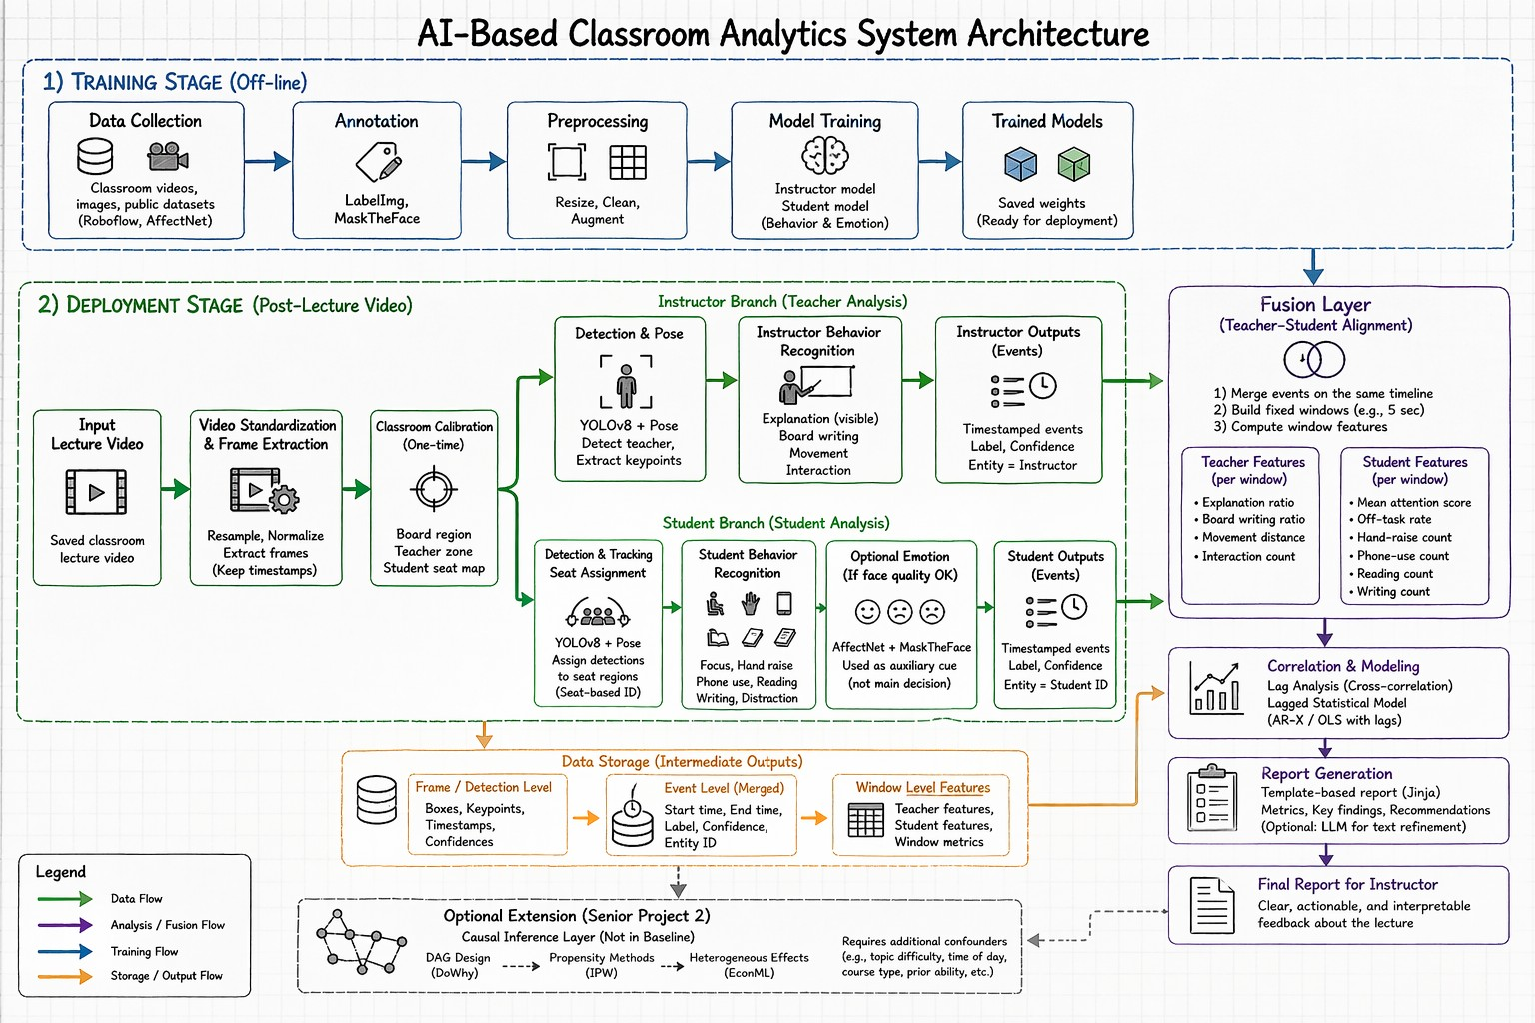
Figure 4.1: Proposed AI-based classroom analytics pipeline.
writing is only counted when the instructor is inside the board region, and student attention is interpreted relative to the teacher and board direction.
The instructor indicators are measured in visible terms. Visible explanation time is estimated from teacher-centered segments in which the instructor is facing the student area and is not writing on the board. Board writing is measured when the instructor overlaps the board region and the detected pose indicates a sustained writing posture. Movement is measured from the instructor position across frames, allowing the system to calculate path length, zone changes, and time spent in different classroom areas. Visible interaction is measured from teacher orientation and gesture-like actions directed toward the student area.
Student indicators are also measured as visible behaviors. Focused posture is measured when the student remains upright and oriented toward the teacher or board for a sustained period. Hand raising is measured using a hybrid rule: the student model must detect a hand-raising action, and a pose check must confirm that at least one wrist is above the corresponding shoulder for several consecutive frames. Reading and writing are treated as separate student action classes learned during training, with pose features used as supporting evidence.. Phone use is modeled as an action pattern rather than relying only on direct phone-object detection, since a phone may be too small to detect clearly in a full classroom view. Distracted behavior is measured when the student repeatedly turns away from the teacher or remains in an off-task state for a sustained time.
For tracking across time, the baseline design uses seat-based assignment instead of full multi-object tracking. Since most students remain in fixed seats during a lecture, each seat can be assigned an identifier, and detections inside that region can be linked over time. This makes the system simpler and easier to explain. More advanced tracking can be added later if needed.
The fusion stage is the core part of the architecture. After both branches finish, their outputs are stored as timestamped events with labels, confidence scores, and anonymous entity identifiers. The lecture is then divided into fixed time windows. For each window,
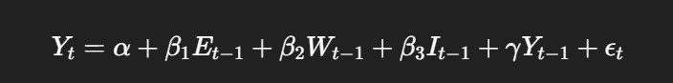
Figure 4.2: Lagged statistical model method
the system computes teacher-side features such as explanation ratio, board-writing ratio, movement amount, and interaction count, and student-side features such as attention level, off-task rate, hand-raise count, phone-use count, reading count, and writing count. The result is a synchronized teacher-student timeline.
The first method in the fusion layer is lag analysis. In simple terms, lag analysis checks what usually happens after a specific teacher action. For example, if teacher board-writing increases, does visible student off-task behavior increase in the next 5 or 10 seconds, or does it remain stable? The system will calculate this by shifting the teacher feature timeline forward relative to the student feature timeline and checking several lags, such as 1 window, 2 windows, and 3 windows. Before modeling, a simple cross-correlation step is used to see which lag values look strongest. SciPy officially provides scipy.signal.correlate for crosscorrelation, and statsmodels provides time-series tools such as autoregression and AR-X style models for lagged relationships.
The second method in the fusion layer is the lagged statistical model. This is the step that quantifies the teacher-student relationship instead of only describing it. A simple example shown in the following figure 4.2
where Y_{t} represents a student outcome in window t, such as off-task rate or attention rate, E_{t−1} represents teacher explanation in the previous window, W_{t−1} represents the boardwriting ratio, I_{t−1} represents the interaction count, and Y_{t−1} represents the previous value of the student outcome. This model is important because it accounts for the fact that student attention usually changes gradually over time. In practice, the implementation can be done with statsmodels using OLS with lagged predictors or AR-X style models from the statsmodels.tsa module. The result is not a proof of causation, but rather a quantified statement such as: teacher action X significantly predicts a later visible change in student behavior Y under the current model assumptions.
The final stage is the reporting layer. The system does not generate conclusions directly from raw video. Instead, it first produces structured metrics and detected events, then fills a report template using the verified outputs. This makes the final report more traceable and easier to interpret. A text-based language model is used only to report the correlations of outputs into a readable-form in certain placeholders.
At the data level, frame-based detections are stored as arrays and then organized into structured tables. These tables contain timestamps, action labels, confidence scores, window IDs, and aggregated indicators. This makes later filtering, merging, statistical analysis, and report generation easier. The final outputs can also be visualized as time-series graphs and summary charts to support interpretation.

4.2 Technologies and Implementation Approach
The system will be implemented mainly in Python, since it provides strong support for computer vision, machine learning, data analysis, and report generation. The core training and deployment packages will be ultralytics, torch, opencv-python, numpy, pandas, scipy, statsmodels, matplotlib, and Jinja2. Video standardization and clip extraction will use FFmpeg as a command-line media tool, called directly through Python subprocess.
In the training stage, the first tools are LabelImg and Roboflow. LabelImg will be used to annotate custom classroom frames for the instructor and student behavior datasets. It is a graphical image annotation tool written in Python with a Qt interface, and it supports YOLO text export, which makes it directly suitable for Ultralytics training. Roboflow will be used after annotation to preprocess the dataset into a standard format. In this project, its main roles are resizing all images to the same training size, auto-orientation if needed, and controlled augmentation for the train split. For the emotion component, AffectNet will be used as the base emotion dataset, and MaskTheFace will be used to generate masked-face samples.
For the main object detection training, the project will use Ultralytics YOLO11, but with two specific variants rather than one universal model. The instructor model will use YOLO11m, while the student model will use YOLO11l. The reason for this split is practical. The instructor usually appears larger, clearer, and less crowded in the frame, so the medium model is enough. The student branch is harder because it must deal with many smaller targets, crowding, desk occlusion, and subtle behavior differences, so the large model is the better choice. YOLO11 pose model will be used as a supporting verifier for a few indicators that are easier to express as body geometry than as pure action labels.
During deployment, the first tool is FFmpeg. FFmpeg will be used to normalize incoming classroom videos into one resolution, one frame rate, and one codec profile, and to cut videos into analysis-ready clips if necessary. It will also be used to extract still frames when creating datasets and to preserve exact timestamps for later fusion.
After that, OpenCV will be used for video reading, frame-by-frame processing, cropping of classroom regions, and drawing preview outputs. This makes it suitable for handling the recorded lecture data before and during model inference. OpenCV’s VideoCapture API officially supports video files, image sequences, and other streams.
For tracking, the system will use seat-based persistent IDs. This is a design choice, not a limitation. Since the lecture is processed after it ends and students are usually seated for most of the session, the system can keep a fixed ID per seat region and accumulate actions over time for that seat.
The fusion and lag-analysis stage will use pandas, NumPy, SciPy, and statsmodels. pandas will store the event tables and window-level feature tables. NumPy will store arrays such as keypoints, bounding-box coordinates, mask overlaps, and lag matrices. SciPy will be used for cross-correlation during lag exploration. statsmodels will be used for the lagged regression models that quantify whether a teacher-side variable predicts a later student-side change.
The visualization layer will use Matplotlib. It will generate plots such as teacher movement curves, attention over time, off-task rate over time, and per-window interaction counts along other statistics.
The report generation layer will use a template-first method. A Jinja template will contain the final report sections and placeholders such as lecture duration, total board-writing time, average attention score, strongest negative lagged association, strongest positive lagged association, and key detected issues. Python will pass the verified metrics into this template and render the final human-readable report text. A text-based language model is used only to report the correlations of outputs into a readable-form in certain placeholders.
This tool selection also supports reliability, security, and performance. Reliability is improved because the system is offline and rerunnable: the same saved lecture can be
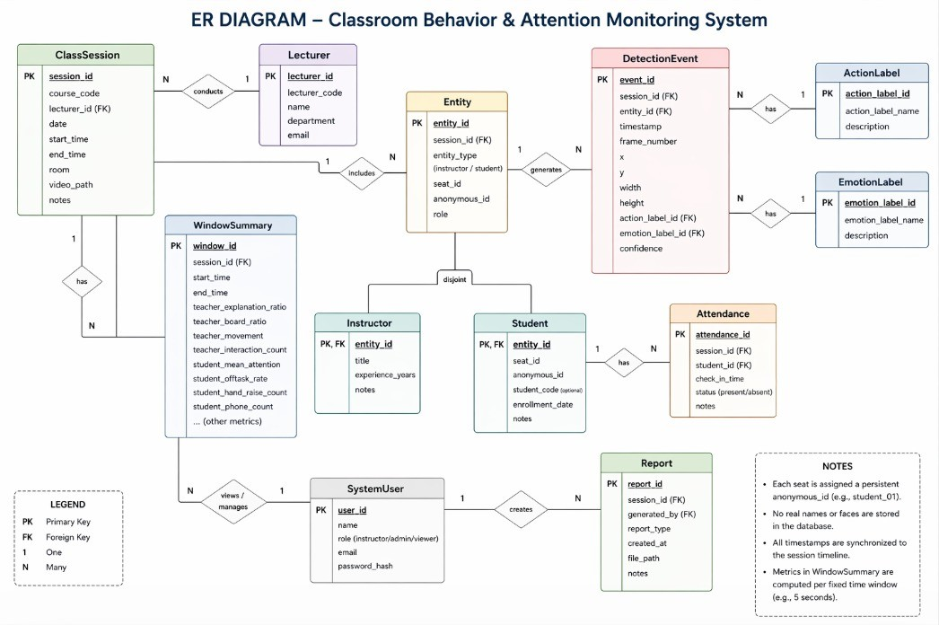
Figure 4.3: ER Diagram
processed again after threshold changes or model updates. Security is improved because the core pipeline can run on local or university-controlled infrastructure without sending the lecture video to an external multimodal API. Performance is still considered, but since the system is post-processing rather than live, the design chooses more accurate models and more explainable stages instead of speed optimization.

4.3 Data and Interface Design
The system’s data architecture centers on capturing all detected behaviors as structured records and then summarizing them over time. At the lowest level, each frame-by-frame detection (with its timestamp, object location, and behavior/emotion label) is recorded as a data point. Crucially, to preserve privacy, we do not store real student names or faces. Instead, each seat is given a persistent anonymous ID (e.g., student 01) .
Once raw events are collected, the system aggregates them into larger time windows. In each fixed window (e.g. 5 seconds), we compute summary features for the instructor and students. In other words, for each interval we record teacher-side metrics (e.g., fraction of time explaining, writing on board, moving) and student-side metrics (average attention score, off-task time, counts of raised hands, phone use, writing, etc.). These tables form a synchronized “teacher-student timeline” that can be analyzed statistically. Importantly, all of this data is stored in standard tabular form (e.g. pandas DataFrames) so that it can be queried like a relational database. In our case, a DetectionEvent or BehaviorEvent record would have attributes such as video id, timestamp, entity id, label, confidence, while a separate ClassSession table holds metadata (course code, lecturer, date, etc.) and an Attendance table logs check-in times and absence status for each student. Linking these tables by foreign keys (e.g., student id, session id) yields a coherent relational design. This is the following Entity-Relationship diagram 4.3
Because our system is intended for instructors, we will choose data representations that make the interface simpler. We will pre-compute only high-level metrics and display them via clear charts, rather than dumping raw arrays. In practice, we will use pandas DataFrames (which behave like labeled SQL tables) to join and filter data. This lets us easily produce summary CSVs for instructors or feed data into statistical models.
The instructor-facing interface will present the processed data in a clear, navigable dashboard. Following prior classroom-monitoring studies, the interface must be user-friendly for non-technical users [6, 11]. We will implement it as a desktop or web dashboard, similar to the remotely accessible web application used in earlier work [11], and it will include the following components:
- Header Bar: Displays context (course code, date, lecturer) and high-level class metrics (e.g., “Overall Attention: 85%”, number of absent students, and total interactions).
- Classroom Video Panel: Shows a snapshot or playback of the lecture video with overlaid annotations. For example, detected student bounding boxes could be colorcoded or labeled (e.g., “Focused,” “On Phone,” “Raising Hand”), as demonstrated in the live report screenshots of prior work [6]. This ground-truth reference helps instructors map abstract metrics to actual scene content.
- Timeline Charts: Line or bar charts plotting attention-related metrics over time. One pane might show the class average attention score across windows, while another could stack proportions of “high-attention” versus “low-attention” student behaviors (focused, reading versus distracted, phone use). We will align charts with the lecture timeline so teachers can identify when attention dipped or spiked.
- Controls and Actions: Buttons or menus for key functions such as Export CSV, Generate Text Report, and Filter by Time/Student. For example, an “Export” button could save the visible table to a spreadsheet, and a “Report” button could trigger the Jinja template to produce the final narrative. These actions will be clearly labeled and require minimal clicks.
Designing for usability and accessibility is paramount. We will use large, legible fonts and high-contrast color schemes so that information is easy to read. No critical information will rely on color alone; each icon or colored bar will also include a text label (e.g., “Phone Use” below a yellow bar) or a shape pattern for color-blind users. The interface will support keyboard navigation and screen-reader compatibility, with descriptive alt-text on charts and buttons, to accommodate instructors with visual or mobility impairments. We will also follow familiar design patterns, such as charts and tables similar to common business intelligence tools, so that instructors need no technical training.
The interface design is further inspired by related work. Prior research demonstrated that overlay cues, such as floating icons and face indicators, can keep a teacher aware of student states without overwhelming them [12]. We will adopt that philosophy by presenting only the most relevant cues—focus, distraction, and participation—and allowing teachers to toggle detail levels. Likewise, related classroom systems emphasize the importance of “live reports” and “user-friendly interfaces” for instructors [6]. Our design aligns with this goal: instead of raw analytics, it presents synthesized insights in plain language, such as “students became off-task 30 seconds after board writing began.”
Finally, the interface will allow export to familiar formats. Charts and tables can be copied into presentations, and options to output a PDF or Word report will be provided.

4.4 Ethical and Innovative Aspects
The design prioritizes student privacy and ethical use of data. All video processing is done offline and locally, and we never link video data to real identities. Instead, each seat is assigned an anonymous ID (e.g., student 01), and we store only structured event records (timestamps, behavior labels, etc.).
Moreover, the system is intended as a teaching-support tool rather than a surveillance mechanism. It provides evidence-based feedback for instructors, not punitive scores for students. Research shows that teacher well-being and behavior significantly affect student engagement [13]. Thus our reports focus on constructive guidance (e.g., recommending more interactive segments or breaks) instead of blaming students or teachers. We apply this by ensuring that any insights or recommendations in the dashboard and reports are clear, action-oriented, and supportive, maintaining trust in the teacher–student relationship.
In practice, deploying the system would require informed consent from school administrators and, if needed, parents or students. The system’s purpose is clearly communicated as improving learning by making teaching more effective, not policing students. Access to the analysis results is restricted to authorized instructors; no external entity receives raw video or personal data. We follow the ethos of responsible AI: all outputs (e.g., attention scores, incident counts) come from quantifiable events, and the system explicitly avoids overclaiming.
The architecture emphasizes long-term viability and efficiency. First, by processing saved lecture videos (not streaming live), the system avoids the infrastructure challenges of realtime monitoring. The pipeline uses open-source, mature tools (OpenCV, PyTorch, pandas, etc.) that are well-documented and maintainable. Data are stored in simple formats (CSV tables or DataFrames) so that future developers or analysts can easily query or extend the system. This aligns with UNESCO’s principle that “quality education for all learners begins with quality data” [9]. In other words, by structuring classroom engagement data into a reliable mini-EMIS for each class, we help institutions make informed decisions about teaching practices and resource allocation.
From a performance standpoint, using a single fixed camera (instead of a complex multicamera rig) makes the system more sustainable in a typical classroom. Kumar (2024) explains that a single-camera setup generates “a single stream of visual data, simplifying data processing and storage requirements,” whereas multi-camera systems produce multiple synchronized streams and heavier computation [4]. Thus we choose a modest hardware setup that most schools can afford and maintain.
Our design incorporates several unique features beyond existing classroom analytics tools. First, it fuses teacher-side and student-side analysis on a common timeline. Unlike simpler systems that only report overall attention or individual face detections, we run parallel detection branches for the instructor and the students and then align their outputs in time.
Second, report generation follows a structured, data-based approach. Instead of sending raw video or loosely defined results to a generative AI model, the system first converts the analysis into clear and measurable indicators, such as “45% of the last five minutes consisted of teacher-led explanation” or “four students were detected using phones during segment 3.” These indicators are then inserted into a report template that produces human-readable observations. This makes the report more grounded in actual system outputs and reduces the chance of exaggerated or unsupported conclusions. It also makes the results easier to export in practical formats such as CSV or Excel for data and PDF or Word for reports, which helps instructors review the findings later or share them with academic departments. Lastly, we incorporate insights from recent educational research to make our system forwardlooking. For instance, Wang and Wu (2025) suggest that AI-based visual analysis can objectively support teaching by quantifying interaction and participation [8]. By aligning with such cutting-edge studies (and by being modular for future multi-modal extensions), our design pushes beyond standard attention trackers.
Chapter 5

Professional, Ethical, and Sustainability Considerations

5.1 Preliminary Cost Estimation and Justification
The proposed system is financially feasible because most of the software stack is open-source, and part of the required computing infrastructure can be borrowed from university labs. The main direct costs are the recording setup, storage, and possible GPU access for training and testing. Since the current scope is a post-lecture prototype rather than a full institutional deployment, the expected cost remains moderate.
Table 5.1: Preliminary Cost Estimation
Item | Estimated  Cost (AED) | Justification
HD camera or suitable phone camera | 500–1200 | Required to capture classroom sessions with sufficient visual quality.
Tripod and mounting  accessories | 100–250 | Needed for stable and repeatable camera placement.
External storage / SSD | 250–500 | Needed to store lecture videos, extracted frames, and generated outputs.
GPU compute access | 0–3000 | May be free if university lab resources are used; otherwise cloud or workstation access may be needed for model training and testing.
Software tools | 0 | The baseline system relies mainly on open-source tools already selected in Chapter 3 and Chapter 4.
Miscellaneous / contingency | 200–500 | Covers adapters, backup media, or small setup needs.
Estimated Total | 1050–5450 | The cost remains manageable, especially if existing university resources are used.

5.2 Relevant Codes of Ethics and Moral Frameworks
This project is mainly guided by the ACM Code of Ethics and Professional Conduct and the IEEE Code of Ethics. The ACM Code emphasizes contributing to society, avoiding harm, fairness, privacy, and high-quality professional work. The IEEE Code emphasizes public welfare, honesty, technical competence, fairness, and responsible professional judgment. These principles are directly relevant because the system processes classroom recordings, produces evaluation-related outputs, and may influence how teaching performance is interpreted.
In practical terms, these codes affect the design in several ways. First, the system uses anonymized student or seat identifiers rather than real names. Second, classroom recordings should only be collected with proper approval and informed consent. Third, the generated report is intended to support instructors, not to replace human academic judgment or be used as a fully automatic decision tool. Fourth, the report is based on measurable system outputs rather than vague AI-generated claims, which supports honesty, transparency, and accountability. These choices align with the ACM focus on the public good and privacy, and with the IEEE focus on fairness, competence, and avoiding harm.

5.3 Relevant Environmental Considerations
The proposed system is designed to reduce unnecessary environmental impact as much as possible within the limits of the project. First, it follows an offline post-processing workflow instead of continuous real-time classroom monitoring. This avoids the need for always-on high-power processing during live lectures. Second, the design prefers a singlecamera setup and reuse of existing university hardware where possible, which reduces both equipment cost and material consumption. Third, the system relies mainly on open-source software, which avoids unnecessary duplication of licensed infrastructure.
The project also aims to reduce waste in storage and computation. Only the data that is needed for analysis and reporting should be kept long-term, while raw videos should be archived securely or deleted after use if university policy allows. During experimentation, model training should be planned carefully to avoid repeated unnecessary runs. Since this is still a prototype, the total environmental footprint is relatively limited, but efficient use of storage, compute, and hardware remains an important design consideration.

5.4 Relevance to UAE and Region (Social, Cultural, and Political)
The project is relevant to the UAE because it aligns with national priorities in both higher education and artificial intelligence. The National Strategy for Higher Education 2030 identifies quality, efficiency, innovation, and harmonisation as its main pillars, while the UAE National Strategy for Artificial Intelligence 2031 aims to position the UAE as a world leader in AI by investing in people and priority sectors. A system that applies AI to improve teaching quality and provide evidence-based feedback fits well with both directions.
The project is also relevant at the social and cultural level. University classrooms in the UAE and the wider region often involve bilingual or mixed-language teaching, and teaching quality is closely connected to student success, institutional quality assurance, and academic reputation. For this reason, the system is designed as a support tool for instructors rather than a rigid scoring mechanism. Its purpose is to help instructors review classroom patterns more objectively while still respecting local expectations around privacy, fairness, and institutional responsibility.
At the regional level, the project also supports the broader move toward digital transformation in education. If implemented responsibly, it can help departments and institutions review teaching practices more systematically and make better-informed academic decisions without relying only on subjective end-of-semester opinions.

5.5 Other Issues and Constraints (where relevant)
One important issue is data privacy and legal compliance. The UAE Personal Data Protection Law, Federal Decree Law No. 45 of 2021, applies to the electronic processing of personal data and establishes controls for lawful processing, confidentiality, consent, correction, and restriction of use. Since classroom videos may contain identifiable personal data, the system must use limited access, secure storage, clear purpose limitation, and anonymized outputs wherever possible.
Another issue is privacy risk management. The NIST Privacy Framework is a voluntary framework intended to help organizations identify and manage privacy risks. Although it is not a law, it is a useful guide for privacy-aware system design. In this project, that means minimizing retained data, avoiding external public AI services for raw classroom videos, and keeping processing on local or university-controlled infrastructure where possible.
There are also accessibility and deployment constraints. Reports and dashboards should be understandable to non-technical academic users and should not depend on color alone when presenting important information. In addition, the system must be treated as an advisory tool because model outputs may still be affected by camera angle, occlusion, lighting, and dataset bias. For that reason, the final report should support human review rather than serve as the sole basis for formal teaching decisions.
Chapter 6

Project Management Plan

6.1 Team Structure
Project team consists of 5 team members, each having certain responsibility while working collectively on all the major parts of project.
Nahyan Al Ali - Project Coordinator In charge of organizing meetings, communication with the supervisor and monitoring the general progress, security measures and identifying risks and feasibility of the project.
Ali Mohammad Zainal- AI/Model Developer Working on application of AI models such YOLO.
Mohammed Alqaidy - Video Processing & Data Management In charge of setting up the process of recording videos and data management.
Ali Algaithi - System Design & Integration In charge of designing the system, integrating various components together.
Abdulla Al kaabi - Documentation & System Evaluation In charge of documenting, reviewing the results of system.
All team members participate in literature study, testing and improvements of system factors.

6.2 Work Breakdown Structure (WBS)
Project Tasks Overview
The project is divided into key stages as showing in the following figure 6.1

6.3 Timeline / Gantt Chart
breakdown would be:
SGP1: SGP2:
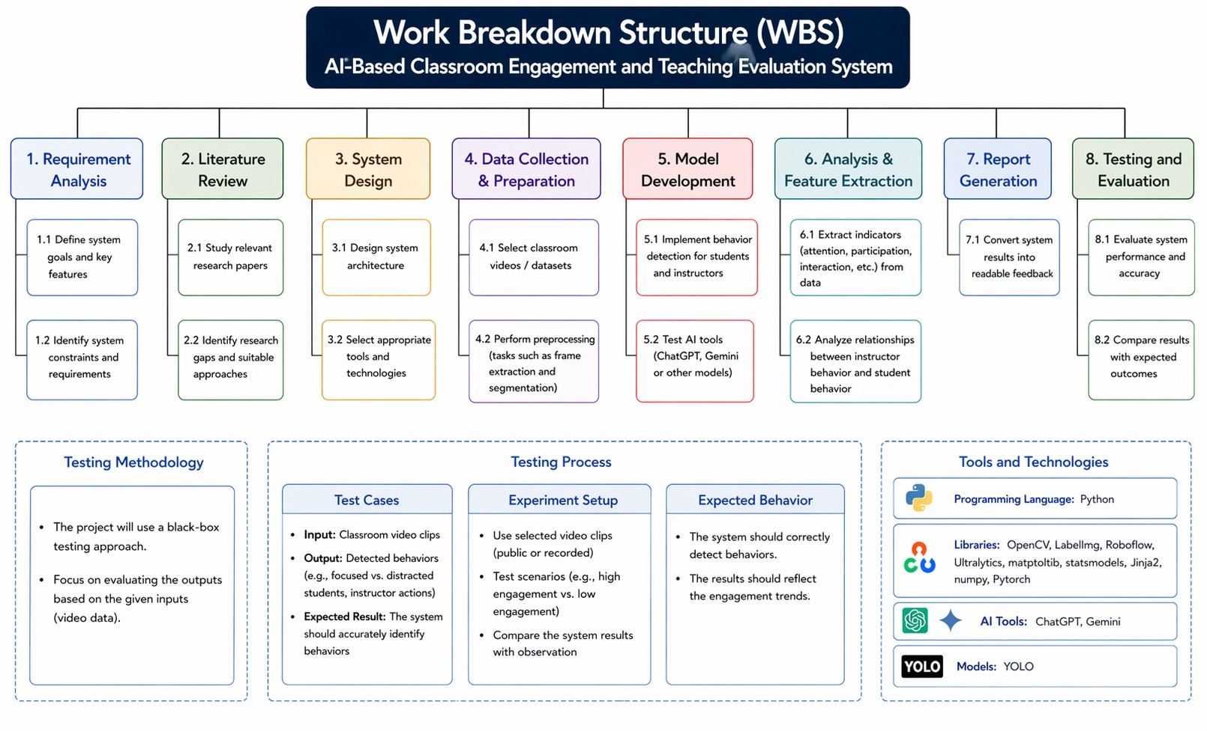
Figure 6.1: Work Breakdown Structure (WBS)
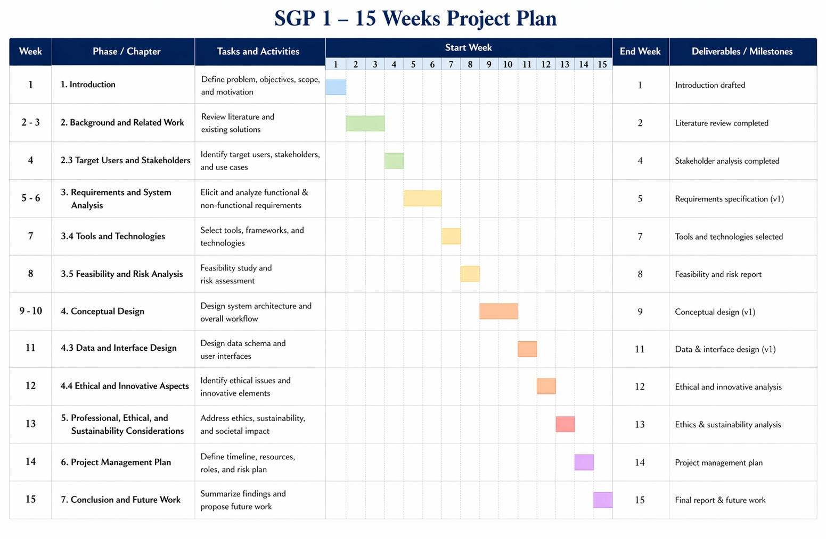
Figure 6.2: Gantt Chart SGP2
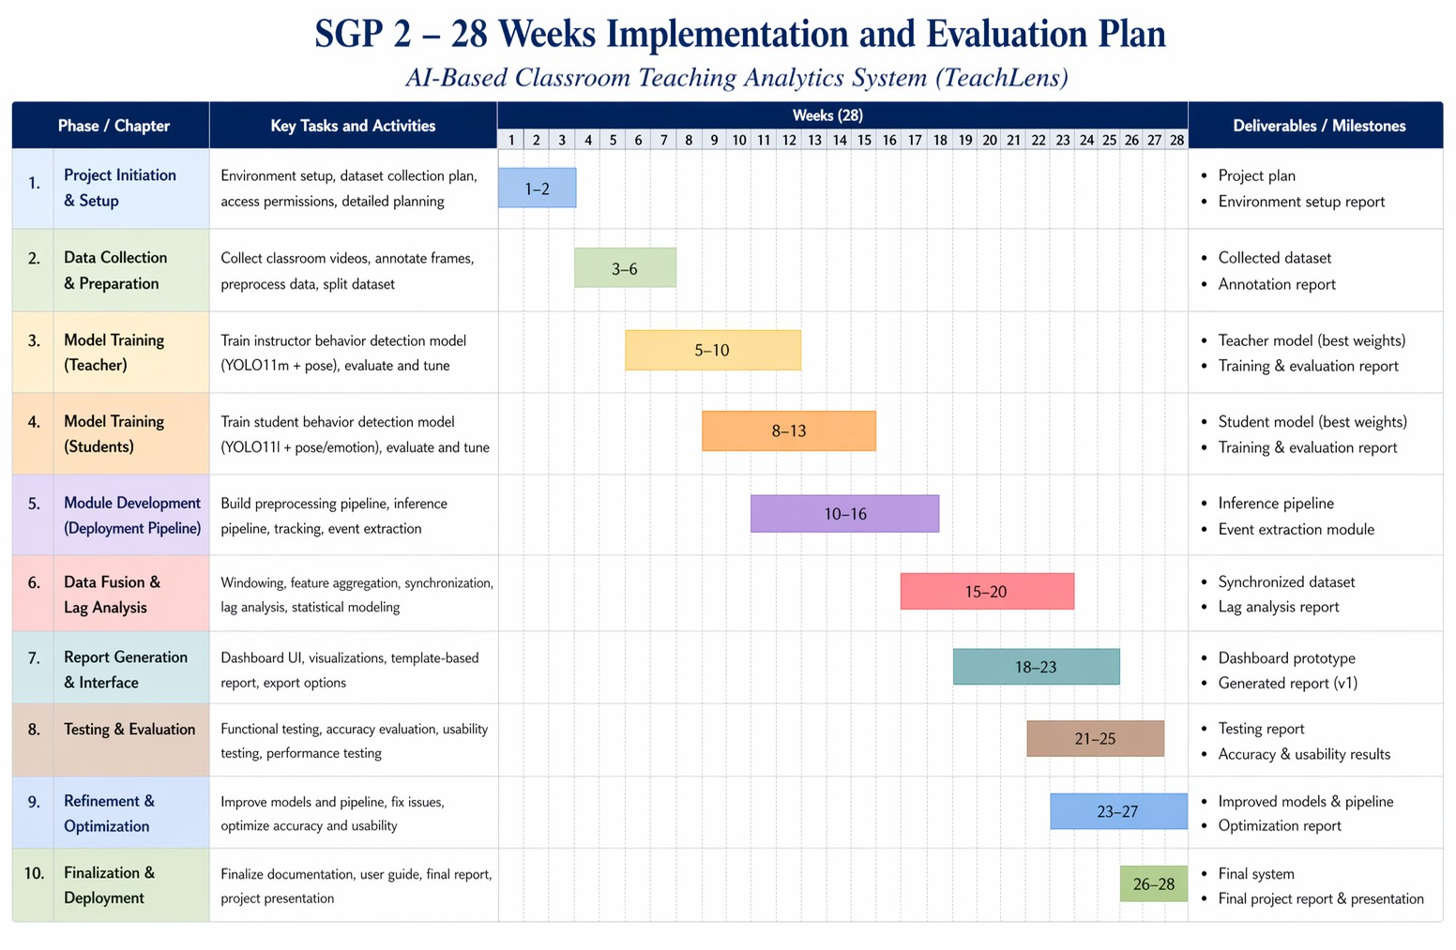
Figure 6.3: Gantt Chart SGP2
Chapter 7

Conclusion and Future Work
This report presented the first stage of the proposed project, TeachLens: AI-Based Classroom Teaching Evaluation System. The main problem addressed in this work is the weakness of traditional end-of-semester course evaluations, which often depend heavily on subjective student opinions and may not reflect what actually happened during the lecture. In response to this problem, the project proposed an AI-based classroom analytics system that uses recorded classroom video to analyze both instructor behavior and student engagement, then generate a structured and more objective evaluation report.
During SGP1, several important parts of the project were completed. First, the problem domain was studied and the motivation of the project was clearly defined. Second, a literature review was conducted to understand how recent research has used computer vision and AI in classroom analysis. This review helped identify the main teacher-side and studentside indicators that can be used in the system, such as explanation time, board writing, interaction, attention, hand raising, and off-task behavior. It also helped identify important limitations in existing work, including privacy concerns, dataset scarcity, occlusion, lighting changes, and weak links between behavior recognition and actual teaching quality.
In addition, the main system requirements were defined. Functional requirements, nonfunctional requirements, standards, constraints, tools, and risk factors were all identified and organized. A conceptual design was also prepared, including the general architecture of the system, the separation between training and deployment stages, the use of two model branches for instructor and student analysis, the fusion stage for time-based correlation, and the report generation layer. The selected technologies, such as Python, YOLO11, OpenCV, pandas, NumPy, SciPy, statsmodels, and Jinja2, were also justified based on the current project goals. Ethical, privacy, sustainability, and UAE-related considerations were also discussed to make sure that the proposed system remains suitable for an educational environment.
Therefore, the main outcome of SGP1 is a complete planning and design foundation for the project. At this stage, we haven’t yet finished the full implementation of the system, but the project idea, scope, requirements, architecture, tools, risks, and expected workflow have been clearly established. This provides a strong base for the second stage of the graduation project.
During SGP2, the focus will move from planning and design into implementation and testing. The first step will be to collect and prepare the data needed for experimentation, including annotated classroom images or short classroom video segments for both instructor and student behaviors. After that, the instructor and student models will be trained and tested. The next step will be to integrate both models into one pipeline, implement the fusion stage, and generate timestamped outputs and lecture-level indicators. The report generation module will then be connected so that the system can produce a readable teaching evaluation summary.
After implementation, the system will be tested on recorded lecture videos to evaluate how well it detects the selected behaviors and how useful the final outputs are. This stage will include checking model accuracy, testing the lag-based linking between teacher actions and student reactions, and reviewing whether the generated report is clear and meaningful. If time and resources allow, SGP2 may also include limited interface development, additional dataset expansion, or an optional extension toward audio and multilingual classroom analysis. However, the main goal of SGP2 will remain the completion of a working prototype and its evaluation on realistic classroom examples.
Chapter 8

Statement of Contribution
3. Requirements and System Analysis | 202205724 | 60%
3.4 Tools and Technologies | 202101929 | 20%
3.5 Feasibility and Risk Analysis | 202100988 | 20%
4. Conceptual Design | 202101929 | 50%
4.3 Data and Interface Design | 202106658 | 25%
4.4 Ethical and Innovative Aspects | 202100988 | 25%
5. Professional, Ethical, and Sustainability Considirations | 202205724 | 40%
5.2 Relevant Codes of Ethics and Moral Frameworks | 202100988 | 20%
5.4 Relevance to UAE and Region | 202100988 | 20%
5.5 Other Issues and Constraints | 202108117 | 20%
6. Project management Plan | 202108117 | 100%
7. Conclusion and Future Work | 202108117 | 100%
Task | Student ID | Contribution Percent
1. Introduction | 202100988 | 100%
2. Background and Related Work | 202101929 | 66.67%
2.3 Target Users and Stakeholders | 202100988 | 33.33%
Table 8.1.
Table 8.1: Student Signatures
Student ID | Student Name | Signature
202101929 | Ali Mihammad Zainal | Ali
202205724 | Mohammad Alqaidy | Mohammad
202108117 | Abdallah Al Kaabi | Abdallah
202106658 | Ali Algaithi | Ali
202100988 | Nahyan Al Ali | Nahyan

References
- Benjamin T. Sharpe, Michael Geoffrey Trotter, and Beverley J. Hale. Sustaining student concentration: the effectiveness of micro-breaks in a classroom setting. Frontiers in Psychology, Volume 16 - 2025, 2025.
- Christian Brandmo and Siv M. Gamlem. Students’ perceptions and outcome of teacher feedback: a systematic review. Frontiers in Education, Volume 10 - 2025, 2025.
- Chuangqi Li, Xinying Weng, Yifan Li, and Tianxin Zhang. Multimodal learning engagement assessment system: An innovative approach to optimizing learning engagement. International Journal of Human–Computer Interaction, 41(5):3474–3490, 2025.
- Prabu Kumar. Single camera vs. multi-camera systems: The ultimate guide. https://www.e-consystems.com/blog/camera/technology/ single-camera-vs-multi-camera-systems-the-ultimate-guide/, December 2024. Accessed: 2026-4-6.
- Hui Wang. Application of artificial intelligence visual analysis technology in classroom english teaching evaluation. Discover Artificial Intelligence, 5, 04 2025.
e
- Zouheir Trabelsi, Fady Alnajjar, Medha Mohan Ambali Parambil, Munkhjargal Gochoo, and Luqman Ali. Real-time attention monitoring system for classroom: A deep learning approach for student’s behavior recognition. Big Data and Cognitive Computing, 7:48, 03 2023.
- Qingtang Liu, Xinyu Jiang, and Ruyi Jiang. Classroom behavior recognition using computer vision: A systematic review. Sensors, 25:373, 01 2025.
- Liam Wang and Xander Wu. Advanced behavioural analysis for classroom instruction: A computer vision approach, 2025.
- Education management information systems progress assessment tool: A — unesco.org. https://www.unesco.org/en/articles/
education-management-information-systems-progress-assessment-tool-methodological-guid [Accessed 10-04-2026].
- Qingtang Liu, Xinyu Jiang, and Ruyi Jiang. Classroom behavior recognition using computer vision: A systematic review. Sensors, 25:373, 2025.
- Michalis Savva, Marco Scarinci, and Pierre Dillenbourg. Recognizing student facial expressions: A web application. In Proceedings of the 13th European Conference on Technology Enhanced Learning (EC-TEL), 2018. Verify conference details and page numbers against your library database.
- Daniel M. Broussard et al. An interface for enhanced teacher awareness of student actions and attention in a vr classroom. In Proceedings of the IEEE Conference on Virtual Reality and 3D User Interfaces, 2021. Verify proceedings title, publisher, and page numbers against the final published version.
- Linda Osterholm, Anna Widlund, and Johan Korhonen.¨ Engagement and burnout in the classroom – crossover effects from teachers to students. Teaching and Teacher Education, 167:105205, 2025.

